**PROJECT REPORT**

**:- INFORMATION SYSTEMS IN HEALTHCARE**

**Table of Contents**

Introduction 2

Idea of cloud computing 2

Types of cloud computing 3

Cloud computing project outline 5

Information systems in healthcare 6

Importance of cloud computing in healthcare 12

The innovative information health system 13

Application of cloud computing in healthcare system 14

Pitch 15

Recommendations 15

Conclusion 16

References List 17

# Introduction

In this project report, the concept of cloud computing has been taken and it is highlighted how it aids in coming up with innovative information in the area of health systems. The concept of cloud computing and also the types of cloud computing has been provided. The information system in healthcare and also the importance of cloud computing in the field of health system management has also been projected. The use of innovative information health systems along with the application of cloud computing has also been analyzed through this project report. Also, recommendations have been provided at the end of the project report in order to aid in cloud computing to provide innovative information health systems.

# Idea of cloud computing

Cloud computing is generally a newly introduced concept in the modern computing area. It may be defined as the act of anything that involves delivering the services of the hosted network over the internet. It can be either private or public (SearchCloudComputing, 2022). A public owned cloud sells the services to anyone over the internet and on the other hand, a private cloud is a data centre that provides services to a limited number of people with access and also requires some permission settings. The goal of cloud computing is to make available easy access to the different resources of computing and also the different sources of Information technology. There is also an infrastructure needed for the effective application of cloud computing to take place and it involves the different components of the hardware and software which is very much needed for the proper application of the cloud computing model. It is also called computing for utility or computing on demand. It depends greatly on the automation and also virtualization of different technologies. The feature of virtualization enables the provisioning of different services and the involving cloud system that the probable users may request and effectively and efficiently utilize and the automation provides users to engage in self-service to find provision for resources, a connection of services and also an allocation of workloads without the consent of the cloud provider. The different advantages and disadvantages of cloud computing may be analyzed from this context.

1. Cost management:- Using cloud computing in the health system helps to reduce capital costs as they don't have to spend money to buy and maintain equipment.
2. Data and workload mobility:- The storage of valuable information in the cloud indicates that users need only a device and internet connection (Abdalla and Varol 2019 ). The end users are provided with easy access to store and recover data from the cloud system in healthcare services and also the storage of different types of information.
3. Business continuity and disaster recovery:- It facilitates business continuity by allowing users to access the different types of data even in the absence of their devices. It also allows the continuous flow of data and information even in the case of disruption of business services.

There are also certain disadvantages in the application of cloud computing:-

1. Cloud security:- Security is one of the disadvantages concerning cloud computing (Rajabion *et al.,* 2019). There is always the risk of any type of breach and hacking and also the issues regarding authentication.
2. Cost unpredictability:- It may become difficult to predict the final cost in order to accommodate the demands of the workload that is fluctuating.
3. Management of multiple clouds:- Managing multiple clouds is a difficult issue as each cloud is different and hampers in addressing challenges in cloud computing.

# Types of cloud computing

There are mainly four types of cloud computing and they are:-

1. Public clouds:- It is a type of cloud system which is not owned by the end-user and created in the IT infrastructure (www.javatpoint.com, 2022). It includes when the environment is effectively partitioned and distributed to the end-users. It does not require any maintenance as it is owned by the end user and it offers a better approach of flexibility to consumers because it is very much easy to integrate. The cloud service provider manages and operates the public cloud.
2. Private clouds:- It is also known as the cloud or the different internal cloud. It is implemented by organizations to build and manage their data centres by assigning the task to any third party. Private clouds provide a greater level of an environment of security and privacy. It initiated an improvement in terms of speed and also the capacity.
3. Hybrid cloud:- It is the combination of the services of both the public and private clouds. It is very much in need because the services that are actually running on the public cloud can be easily accessed by anyone while the services in the private cloud can only be accessed by the provider of the service.
4. Community cloud:- It facilitates the different systems and services to be accessible by a number of organizations in order to share the information with a specific community. It is generally owned and managed by a specific organization or even more than that. It is very much cost effective as it is controlled by different organizations or communities and it has much higher security as compared to the other forms of cloud computing. It allows sharing of information and resources among the various organizations. It operates in an environment which is collaborative and distributive.

All the advantages and dis-advantages of the several types of cloud computing may be efficiently and effectively assessed so that a feasible cloud computing system may be introduced to provide an environment that facilitates better implementation of the informative innovation health services. Cloud computing can provide better organization of the different healthcare services in the storage of the vital information in the healthcare services and also the better implementation of the respective cloud computing services with a view to enhance the modern healthcare services provided by the healthcare service providers.

# Cloud computing project outline

| **Area** | **Particulars** |
| --- | --- |
| **Cost** | The cost to be incurred in the project is around £ 800 billion. |
| **Scope** | The public and private healthcare services can use it.  They can have a better understanding of cloud computing. |
| **Milestones** | The milestone that is to be achieved is the effective implementation of cloud computing as a means to provide an innovative information health system. |
| **Risk factor** | The risk factor involved in the project is the risk of financial resources. |
| **Aim of the project** | The aim of the project is that cloud computing will result in better security of patient vital information and also the level of communication will increase. |
| **The output of the project** | The output of the project is the better implementation of cloud computing in the innovative information health system. In addition, the overall administration system can also be developed with cloud computing implementation. |
| **Requirement of the resources** | The project required different software and the human resources involved in the project. |

**Table1:- outline of the project**

(Source: Keikhosrokiani *et al.,* 2020)

# Information systems in healthcare

A healthcare information system is defined as the management of different types of data related to healthcare. It includes all the systems that are required to collect, store and the management of a patient's data in the form of an electronic record and also facilitates decision making in terms of policies pertaining to healthcare services (Keikhosrokiani *et al.,* 2020). The systems handle different types of data that are related to the various activities involved in providing the healthcare services being provided by the different healthcare providers and the organizations relating to health. It includes integration of the different types of services created to provide a great level of improved patient outcome and also devising ways to influence the various policy-making and the decision-making capability of the healthcare service providers. Security is one of the most important areas of concern in terms of handling large volumes of sensitive data. The introduction of the Electronic medical record and the electronic health record provides a more feasible way of storing vital information of the patient's health condition and also the different types of data relating to the different results of the test conducted and the treatments provided.

**Application of cloud computing in National Health Services (NHS) UK.**

* **How NHS is transforming its services with cloud technology adaption: -**

In terms of keeping development of the work standard, this would require focus on the innovation development by making implementation of the cloud computing process. Application of the cloud computing would allow the development of the healthcare technologies by making implementation of patients portals, electronic medical records and also the application of the big data analytics. For the maternity wards, the documentation process can also be done regarding the allotment of the nurses, equipments details as well. Thereby, the operational risks can be reduced relating to the application of the cloud computing system.

NHS Digital's work exemplifies how the health-care system is embracing the cloud.

It is the national information and technology partner for the UK's health and care system, and a big believer in the cloud's capacity to bring flexibility and cost savings to NHS organizations while protecting privacy, security, and compliance. It has adopted a cloud-first, multi-cloud strategy that allows it to select the most appropriate cloud for each workload.

**NHS digital wing: -**

NHS Digital has traditionally used VMware on-premises, but it also uses Amazon Web Services (AWS) and Microsoft Azure public clouds extensively. Cloud services could be the key to increasing productivity and meeting demands. NHS Digital recently announced that public cloud services are a secure place for healthcare professionals to keep personal patient data. This is only possible if certain data sovereignty requirements are met. In addition, official recommendations were developed to assist healthcare and social care organizations in moving data from on-site servers to cloud services in a safe and secure manner. NHS Digital declared in January 2018 that it would take a "cloud-first" strategy to technology in the NHS and released formal recommendations on cloud computing for health and social care. This is a crucial step toward giving the NHS clarity on how to store patient data on the cloud. In practice, this means that the Health Secretary has granted the go-ahead for public health organizations to shift data from on-site computers to cloud services hosted by Amazon, Microsoft, and UKCloud.

Cloud-based applications can improve patients' relationships with the NHS and their own health by allowing them access to and control over their own care. Arthritis Research UK, for example, has unveiled a cognitive virtual assistant powered by IBM Cloud and AI and trained by experts to give customized support for arthritis patients. Service provided new insights into the ailment in addition to responding to enquiries 24 hours a day, seven days a week. Many outdated NHS systems lack security, which cloud computing provides. Strong security measures are essential for preventing data breaches and restoring public trust. IBM's services provide with built-in security and can be deployed entirely on UK-based infrastructure.

**'Pre-cloud support,** which includes a review of an organization's present condition, cloud readiness assessments, architecture design, and migration planning, is the emphasis of 'Solution Design and Consultancy.' This is particularly useful for organizations considering migrating from outmoded legacy infrastructure to public or private cloud, as well as those who have already taken the first steps but require more assistance to go to the next stage of adoption.

**‘Infrastructure as a service (IaaS), Platform as a service (PaaS) and Software as a service (SaaS)’** covers public cloud and/or private and hybrid cloud hosting, processing, storage, networks and applications. The services here are for organisations looking to source the core infrastructure for cloud computing with a range of connectivity options.

**The term 'end-to-end cloud solution'** refers to the process of locating a reliable partner who can provide complete start-to-finish support for a company's cloud journey.

The framework is valid through September 2021, with a two-year extension option, and allows public-sector users to make direct awards or hold smaller competitions to meet their specific needs.

The framework also encourages suppliers to bring forth innovative new goods and solutions to benefit the public sector during the term of the agreement, reflecting the fast-evolving nature of the sector.

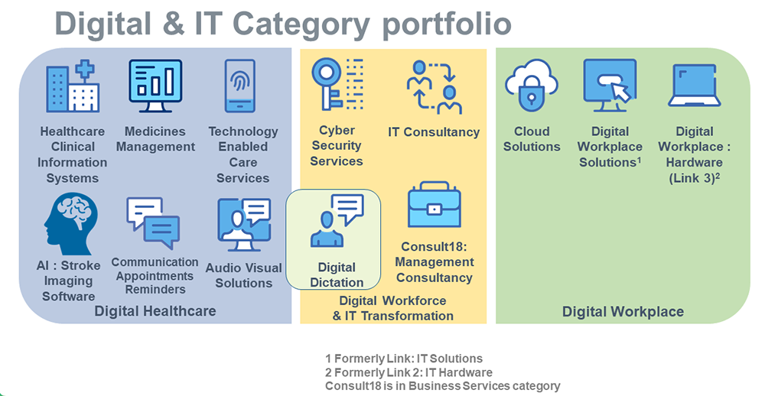

Figure 1 NHS’s cloud architecture portfolio for IT transformation

IBM’s cloud partnership with NHS, (source - The encrypted data in cloud computing, 2018)

**NHS Login identity platform:-**

NHS login is a digital identification platform that enables individuals in England to register, log in, and use a variety of healthcare apps, including the NHS app. The programme allows users to identify themselves and link their healthcare records using their NHS number in an easy and secure manner. Users may access a wide range of services, including general practice (GP) appointments and medications, more quickly and easily using NHS login.

The COVID-19 epidemic boosted demand for NHS login, and the AWS Cloud assisted them in scaling to meet it. NHS login currently has over 17 million verified users and allows all inhabitants of England to register and log in. Over the course of the year, the number of confirmed identities on NHS login increased by 660 percent, from 238,638 in January 2020 to 1,815,220 in December 2020. NHS login had an average of 108,000 individual users enrol for the service in June 2021, with 774,000 individuals using their NHS login account to access healthcare applications during the month, demonstrating its ability to scale to demand in the cloud. More than 40 internal and external services, including myGP and e-RS, are currently integrated with NHS login.

**NHS platform data collection.**

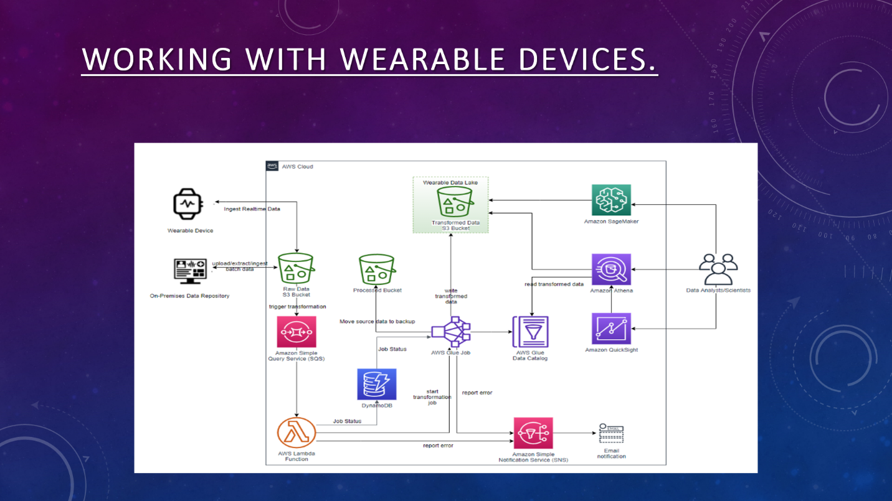

**Figure 3:- how data collection works**

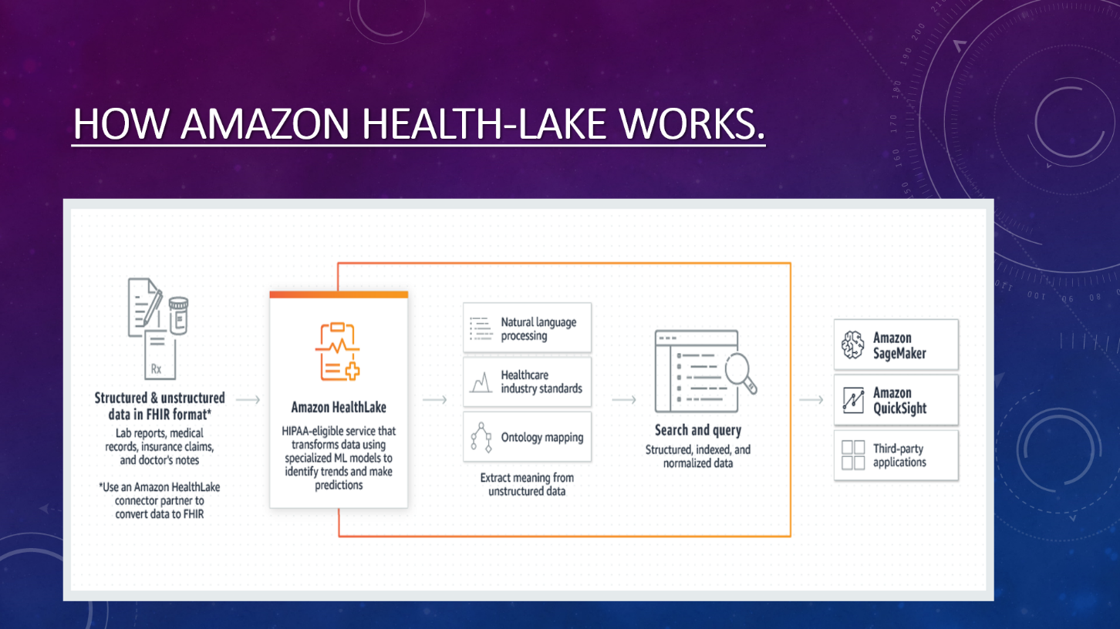

**Figure 4:- Data interpretation using cloud service**

**How cloud technology helps NHS for their GP to study the adverse reaction of COVID 19 reactions.:-**

The DPS is an Amazon Web Services (AWS) service running Databricks and making use of many cloud-native AWS managed components. It is capable of receiving large amounts of vaccine event data from the point-of-care applications and processing this using a set of data quality and other business rules. The Data Processing Service can also forward the relevant data to authorised 3rd parties such as the patient’s GP record and the Medical and Healthcare Products Regulatory Agency (MHRA) to allow them to monitor adverse reactions. One of the key functions of DPS is to undertake data quality checks to drive up the quality of data captured, received and processed downstream. We are currently on target to drive down the error rate to 0.11% which, given the scale of the programme and the diversity of delivery models, is a massive achievement. This has been very important to the recently launched NHS COVID Pass service, which uses this data.

This would require to gave the practice management software is also introduced which helps in managing the daily operations of the billing and the cash management and also has been automated to facilitate the different types of works of the administration (Sharma *et al.,* 2018). The master patient index which helps in connecting several patient records in the database and the Index are used to check duplicacy of patient records and also the inaccurate information regarding the patient that will ultimately disrupt the healthcare services. The patient portal in the hospital administration through which patients can access their health data pertaining to information about their appointment with a doctor, different types of medications they are taking and their test reports can be assessed over the internet. The Report patient monitoring system is also an added component in the healthcare management system which provides sending patient information to the professionals of the healthcare services. It helps in monitoring the glucose levels in the blood and the checking of blood pressure in patients. Another feature is the clinical digital support which analyzes data from different systems relating to the systems of the clinical and administration with an intention to help the different healthcare providers who are engaged in making clinical decisions.

# Importance of cloud computing in healthcare:-

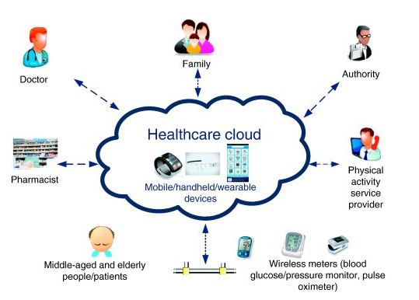

**Figure 5: Use of cloud computing in health care**

(Source: Quasim *et al*., 2019)

The following are the different importance of cloud computing in the healthcare system:-

1. In today's healthcare service the cloud computing has been extensively used by the different hospitals and by different service providers in order to replace the paper record keeping all the information electronically in the cloud and also upgraded and updated by different healthcare service providers.
2. Healthcare providers can use the information from cloud computing to provide support to collaborative patient care (Quasim *et al*., 2019). A patient may have different types of files of health services taken from different hospitals and for this reason, it becomes very difficult to collaborate the different findings. It gives ample scope for healthcare providers to share information among themselves and provide the best possible healthcare service to the patient.
3. Cloud computing in healthcare reduces data storage costs by giving an edge over the healthcare service providers in maintaining the cloud-based storage devices at a much lower cost and allowing healthcare providers to maintain their duty of taking care of the patients.
4. Engagement of cloud computing in healthcare services provides a great opportunity for data storage and security by creating an infrastructure that cordially supports on-site data storage. The data storage of patients should follow all the legal requirements necessary to be followed in order to provide the security of data and also data privacy.
5. Another important point for the inclusion of cloud computing in the healthcare services is to enhance the safety of the patients (Yoo and Kim 2018). The introduction of the cloud EMR solutions has provided healthcare service providers with an ability to gain deep information about the interaction of the patient with the different physicians located at different healthcare establishments. This has greatly helped to save patients from the over-prescribed medications that may result in causing severe harm to the patient.

# The innovative information health system

The following are the different innovative information in the healthcare system:-

1. Next-generation sequencing:- It is the conduct of sequencing the different techniques with regard to offering a more enriched high output and also the element of speed (Garapati and Garapati 2018). It is generally used in the activity to determine the high-risk populations and provide sufficient guidance and therapies to the prospective patients who are very much likely to respond.
2. 3D printed devices:- Medical equipment are produced with the help of 3D printed devices so that these can be effectively used by patients according to their needs. Different types of orthopaedic instruments and surgical instruments are made with the help of 3D printing.
3. Artificial intelligence:- It is the application of various computer-aided machines and software in the healthcare industry to complete the various types of activities performed by humans with much higher speed, accurate information and delivery of test result in a more conducive manner by utilizing minimum amount of resources in the process of the innovative healthcare management system.
4. Telehealth:- It is a feature introduced in the healthcare system which acts in providing better healthcare services by engaging patients in self-care where they can consult with any doctor over the internet without visiting the doctor's place (World Health Organization, 2019). This will surely relieve patients from the different types of complications and the emergency situation.
5. Immunotherapy:- It is a type of treatment given to patients who are suffering from cancer. It is more of a biological study and the immune system of a patient is made stronger to fight cancer. It extracts required substances from the living organisms to provide suitable and sustainable treatment to the patients who are fighting the disease of cancer.

# Application of cloud computing in healthcare system

The application of cloud computing in the healthcare system has greatly affected the implementation of the different innovative technologies in the field of healthcare services (Akpan *et al.*, 2021). Cloud computing has been extensively used to provide a platform that initiates secure patient data and also by compliance with the different regulatory compliance and by creating a space for the healthcare service providers to provide care to the patients. Essential applications are involved in order to keep the different operations running without any problem and help doctors to diagnose in a better way and also enable patients to have a view of their test report. Cloud computing offers different operational, functional and also the different economic benefits to everyone involved in the healthcare service. A healthcare solution that is based on the cloud environment will absolutely help in enhancing the care of the patient. It also enables us to adjust the infrastructural facilities in order to facilitate new data in the cloud computing system. The healthcare system of the UK can really benefit by implementing cloud computing in its daily operations. It is believed that the NHS trust have more potential in cloud computing (Microsoft Industry Blogs - United Kingdom. 2022). By implementing cloud health industry of the UK will be able to maintain electronic medical records, develop patient portals, establishing mobile apps, enabling their medical devices with IoT as well as big data analytics. Hence, by implementing the cloud in the UK health sector the organisation will not only be able to take advantages of cloud but will also be able to improve care team productivity and collaboration and efficient access to patient care.

# Pitch

In this project report, the importance of cloud computing in the modern innovative information health system has been highlighted. Also the definition of cloud computing along with its advantages and disadvantages and also the outline of the project relating to health care. The different innovations in the area of healthcare innovative systems and the effective application of the cloud has also been provided in this project report. The project also provides details about the different facilities that cloud computing can have in the context of the services associated with healthcare and involvement in the different activities that needed to be followed so as to facilitate better understanding of cloud computing. The risk factor which is involved in the project is the risk of available financial resources that are needed for the conduct of the project. It will help in storing the vital information of the patients and a better environment by the implementation of the different innovations in the information health system.

# Recommendations

The procedure of cloud computing increases the efficiency of the hospitals and other healthcare centres and cost is decreased which is quite naturally a benefit for the healthcare industry. The Cloud computing system should be increasingly used in hospital as it is an essential need for the improvement and development of the healthcare industry because

* Through cloud computing, the health treatment facilities can be improved during emergency situations.
* Through cloud computing, cloud storage will lead to the keeping of records in an efficient and proper way
* The process of cloud computing will prove to be more reliable and secure. Therefore it should be used in healthcare sectors

# Conclusion

The project report that is undertaken issues a critical evaluation of the importance of cloud computing and the use of cloud computing in healthcare institutes for the benefit and improvement of the healthcare institutes. The concept of cloud computing, the pros and cons of cloud computing has been mentioned. The project outline of cloud computing, the information system in healthcare institutes, and the significance of cloud computing have been analyzed in detail. Further the project includes the importance of the health system, innovative and unique information in the health system. The project ends with the application of cloud computing in the healthcare system and recommendations behind the use of cloud computing in institutes of healthcare.

# References List

Abdalla, P.A. and Varol, A., 2019, June. Advantages to Disadvantages of Cloud Computing for Small-Sized Business. In *2019 7th International Symposium on Digital Forensics and Security (ISDFS)* (pp. 1-6). IEEE.

Akpan, I.J., Soopramanien, D. and Kwak, D.H., 2021. Cutting-edge technologies for small business and innovation in the era of COVID-19 global health pandemic. *Journal of Small Business & Entrepreneurship*, *33*(6), pp.607-617.

Garapati, S.L. and Garapati, S., 2018. Application of big data analytics: an innovation in health care. *Comput Intell*, *14*(1), pp.15-27.

Keikhosrokiani, P., Mustaffa, N., Zakaria, N. and Abdullah, R., 2020. Assessment of a medical information system: the mediating role of use and user satisfaction on the success of human interaction with the mobile healthcare system (iHeart). *Cognition, Technology & Work*, *22*(2), oT and cloud-based healthcare systems. *IEEE Internet Computing*, *22*(2), pp.42-51.

Microsoft Industry Blogs - United Kingdom. 2022. *How the cloud is helping the UK healthcare industry - Microsoft Industry Blogs - United Kingdom*. [online] Available at: <https://cloudblogs.microsoft.com/industry-blog/en-gb/government/2017/08/08/how-the-cloud-is-helping-the-uk-healthcare-industry/> [Accessed 18 April 2022].

Quasim, M.T., Johri, P., Meraj, M. and Haider, S.W., 2019. 5V’s of big data via cloud computing: uses and importance. *Sci. int (Lahore)*, *31*(3), pp.367-371

Rajabion, L., Shaltooki, A.A., Taghikhah, M., Ghasemi, A. and Badfar, A., 2019. Healthcare big data processing mechanisms: The role of cloud computing. *International Journal of Information Management*, *49*, pp.271-289.

SearchCloudComputing, 2022. *What is Cloud Computing? Everything You Need to Know*. [online] SearchCloudComputing. Available at: <https://searchcloudcomputing.techtarget.com/definition/cloud-computing> [Accessed 1 January 2022].

Sharma, S., Chen, K. and Sheth, A., 2018. Toward practical privacy-preserving analytics for IoT and cloud-based healthcare systems. *IEEE Internet Computing*, *22*(2), pp.42-51.

World Health Organization, 2019. *WHO guideline: recommendations on digital interventions for health system strengthening*. World Health Organization.

www.javatpoint.com, 2022. *Types of Cloud - javatpoint*. [online] www.javatpoint.com. Available at: <https://www.javatpoint.com/types-of-cloud> [Accessed 1 January 2022].

Yoo, S.K. and Kim, B.Y., 2018. A decision-making model for adopting a cloud computing system. *Sustainability*, *10*(8), p.2952.

Element 3: individual project report

**UNIVERSITY OF WEST LONDON**

**School of computer and engineering**

**Project Report**

**Health data analysis using Cloud service**

Date of submission: 30/01/2022

**Project title:** - Advance health data analysis by using AWS

health lake.

**Aim of the project**: -

This project is made with proposed plan of how cloud computing can help

to track and provide effective and accurate health data report by the installation

of state-of-the art health sensors. Moreover, in this project the idea of using

cloud-based data analytics software called “AWS health lake” which is designed

and developed by amazon incorporation. In this project the idea about using the

wearables as an object of data gathering of users. Furthermore, the mechanism

of data gathering conducted by health data sensors are also featured.

This presentation also includes the overview of what is cloud computer, the

concepts of cloud computer and different service models offering by cloud

service providers. Our group also tried to cover all the important aspect of cloud

computing business models along with the benefits of using cloud services.

The third aspect behind presenting this project is to deliver how wearables can

become an identical and important asset for data gathering, data analysis and

patient safety, it can also help to create a highly effective drug development and

disease control. The fourth aspect which our group tried to cover is to show how amazon backends to support its health data analysis service called “Health Lake” has tried to covered the overall computational mechanism about how data gathering, data processing and data analysis happens at the back end. I am entirely responsible for a few quests, all of which have since been completed or are currently being worked on. Designing and executing a cloud service is one of these responsibilities. I decided that showing the data analysis values caused by the data gathering was the best option, presuming that our users would have some technical understanding.

**My role and contribution:**

As a founding member of group. I and my other group member had decided to

go ahead with our personal field of interest. As I having a deep interest in cloud

technologies and infrastructure, I have decided to took the cloud side, which

includes the information gathering about how cloud technologies work, what

are the benefits of cloud computing and how cloud technologies can create an

effective way to create a sustainable solution for accurate data analysis. My duty

also includes the induction about AWS’s “health lake” and its working pattern.

In slide number 6 I have tried to give and detailed explanation about sensors

from wearables gathers the data from user’s body and how the algorithm

calculates and transfers the data to amazon’s advance servers where all

calculation and data processing happens. As a part of our research I have also identified some of the best practice During the presentation, I have tried to explain the detailed pictorial presentation about how an advance algorithm process the gathered data from

the wearables and the cloud-based service approaches can create an advance

solution towards drug making and effective patient treatment.

**Benefits of using amazon health data analytics using cloud computing: -**

1. Quickly and easily ingest health data – it can bulk import on-premises fast

healthcare interoperability resources (FHIR) files, including clinical notes,

lab reports, insurance claims, and more, to an amazon simple storage

service (amazon S3).

2. Health-lake stores data in complete, chronological view of each patient’s

medical history, and structure it in R4 FHIR standard format.

3. Health-lake also supports FHIR CRUD (create/Read/Update/Delete and

FHIR search operation.

4. Health-lake helps healthcare organizations analyse population health

trends, outcomes, and costs. This helps organization to identify the most

appropriate intervention for a patient population, and choose better care

management option.

5. Amazon health lake is cloud based high performance health data analysis

service provided by amazon web service limited, this data analysis service

is aim to provide to store, transform, query and analyse data in the AWS

console using natural data processing (NLP) capabilities, it can also analyse

unstructured clinical text from diverse sources.

**Overall team performance: -**

While considering all the factors and overall group performance, I personally

observed couple of spaces which can be filled with the potential to do better in

group project outcomes. Such as

1) More In depth and qualitative research could be provided and as a final

result the process and data gathering could be better described

2) The information about cloud computing and the service offering by the

AWS could be broadly described.

**Accurate critical patient data analysis by using AWS Health-lake.**

The group will receive a summary of the client's information, including the plan's

purpose, goals, and reasons, led by the group leader.

**A synopsis of the work is as follows:**

Working with other group member, to help them develop the system's user

interface and interactions for use in the workshop, is an important part of your

data gathering model. To do so, you'll need to consider the systems in terms of

labour division, inventory management, and the fact that IS will need to share

data with them. At this point, the project's scope will be determined through a

collaborative agreement between the users and the system. - This project is

based on a proposed method for using state-of-the-art health sensors to track

and give effective and accurate health data reports via wearables.

Furthermore, in this project, the notion of employing Amazon's cloud-based

data analytics software dubbed "AWS health lake" was conceived and

constructed. The concept behind this project is to employ wearables as a data collection tool for consumers. Furthermore, the data collection mechanism used by health data sensors is

discussed.

**Summary:**

The final analysis depicts the proper findings of this projects about how data

analysis could be improved by using cloud services offered by AWS. The high-tech

sensor’s deployment in wearable can be seen as a breakthrough for this

segment. This project is an overall understanding about data analysis.